The general problem: Developing a semi-automatic industrial drum filling machine whose production cost results advantageous against existing equipment that needs to be imported.

PROJECT 1 – SEMI-AUTOMATIC DRUM FILLER SUBSYSTEMS

The filler is an open kinematic chain with four joints, some of which are manually moved by an operator, and some of which are actuated by an electronic controller. The end effector is a nozzle that can be opened and closed to dispense some fluid into containers of known size (the flow is also regulated by pneumatic ball valves). During a filling process, an operator manually places the nozzle over the opening of a container and then starts an automatic filling cycle. In this cycle, the nozzle is lowered into the container and its valve is opened to allow liquid to fill the drum. Once a desired weight of material has been reached, the valve is closed and the nozzle raised.

Some development has already been made in this project. However, some subproblems are yet to be implemented or could possibly be solved in better, more failsafe ways:

1. Selection or design of a control algorithm for the automatic vertical motion of the nozzle (avoiding oscillations and excessive overshoot around its commanded position), and selection or design of a control algorithm for the flow control valves to ensure a very precise quantity of dispatched liquid. If possible, this should be implemented in the programming language provided by the digital controller’s manufacturer.
2. Implementation of the electronics needed to track the vertical position of the nozzle and to feed that information as a 4-20 mA signal into de digital controller. Additionally, development of the circuitry necessary to either store the last known position or keep the dedicated microcontroller functioning during a power outage.
3. Proposal to combine a variety of signals (weight, velocity, etc.) to detect a collision of the nozzle against the container and abort the process.
4. 3D CAD of the complete armature to aid in the definition of dimensions and the estimations of weights, moments, reachable work area, and other parameters useful for documentation).

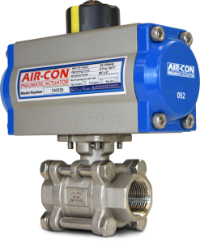

Example of a pneumatically actuated liquid valve.

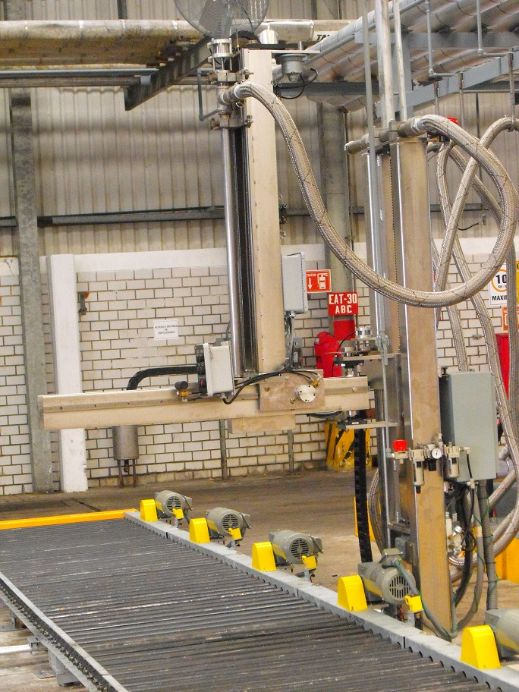

Example of an existing semi-automatic drum filler.

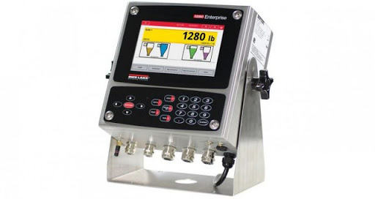

1280 programmable weight indicator and digital process controller.

PROJECT 2 – VISION SYSTEM FOR AUTOMATIC DRUM FILLER

The drum filler from the first project might evolve to become a fully automatic system that only requires an operator to start the process, stop it, or change some variables. An automatic filler should be able to detect the position of each drum’s opening, perform a horizontal movement to align the nozzle with the container and perform the same automatic filling cycle as in the semi-automatic model. This can be accomplished with a camera and a vision algorithm.

Since the drums placed below the machine could be in any orientation, be manufactured or painted in different colors, have stains or rust, and since the machine could be installed under various lighting conditions, on top of a floor or platform with any kind of patterns, it is very important to have a robust vision system that finds all of the containers’ openings and only the containers’ openings.

The problem here is to find or design a vision algorithm that can find the openings of drums of a known type, under a variety of conditions, and producing a series of coordinates in space that can be transmitted to the digital controller so that it may perform the required motions to align the nozzle within a tiny tolerance. This algorithm should then be implemented as an embedded system so that it can be installed alongside any filler designed for automatic operation.

The exact design of this machine is not yet defined, so any kinematics calculations to reach a target point will be the responsibility of the controller, not of the vision system.

An example of an existing filler with vision system can be seen here: <https://youtu.be/_cLrsJu9RNM?t=40>

Possible typical drum configurations as seen from above:

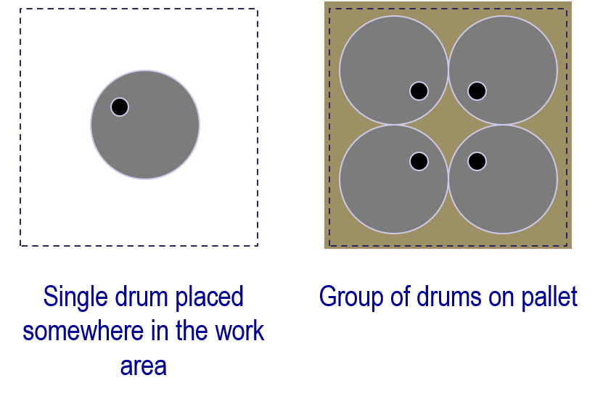

Examples of 55-gallon drums

